**Cyber Cloak**

**Field of Invention**

The present invention pertains to the field of cybersecurity and internet privacy, focusing on creating an advanced, multi-tiered system to ensure secure and anonymous internet browsing. Specifically, it relates to a novel system and method for providing secure virtual private network (VPN) access through a specialized software application named Cyber Cloak. This system integrates a combination of VPN technology, real-time vulnerability scanning, and dynamic IP management to enhance user privacy and protect against cyber threats. The invention aims to provide seamless and effective anonymity by masking the user's IP address, securing internet connections, and preventing unauthorized access to sensitive data. Moreover, it features robust vulnerability scanning capabilities, making it an ideal solution for users seeking advanced security and privacy while accessing the internet. This system is designed to be intuitive, user-friendly, and highly efficient, catering to a wide range of use cases from general users to professionals and businesses that require secure network connections.

**Background of Invention**

The internet has become an essential part of our daily lives, providing convenience and connectivity. However, with the increased use of the internet for personal, professional, and financial activities, the risks to privacy and data security have significantly escalated. Cyberattacks, including hacking, identity theft, phishing, and online surveillance, are now more frequent and sophisticated, putting users' sensitive information at constant risk. This has raised the demand for tools that protect user privacy and safeguard data during online activities, leading to the growing adoption of Virtual Private Networks (VPNs).

While VPNs offer privacy benefits, many existing solutions suffer from shortcomings such as slow performance, limited server availability, or overly complex user interfaces, which make it difficult for individuals to benefit fully from the technology. Additionally, many VPN services focus mainly on masking the user’s IP address without providing any tools for real-time vulnerability scanning or protection against potential breaches. Furthermore, the inability to dynamically change the IP address while connected to a VPN leaves users vulnerable to tracking mechanisms that undermine the privacy protections offered by traditional VPNs. Thus, a new solution is required to address these gaps in security and improve both user privacy and safety online.

Cyber Cloak presents an innovative solution to these challenges. By combining VPN encryption with enhanced security measures such as real-time vulnerability scanning, Cyber Cloak protects users from both externa cyber threats and internal security weaknesses. Additionally, it introduces the ability to dynamically change the user’s IP address, even while connected to a VPN, ensuring maximum anonymity and making it difficult for malicious actors to trace the user’s online activity. Through this combination of features, Cyber Cloak provides a comprehensive, user-friendly security solution that not only maintains privacy but also proactively prevents cyber threats in a seamless and efficient manner.

Cyber Cloak presents an innovative solution to these challenges. By combining VPN encryption with enhanced security measures such as real-time vulnerability scanning, Cyber Cloak protects users from both external cyber threats and internal security weaknesses. Additionally, it introduces the ability to dynamically change the user's IP address, even while connected to a VPN, ensuring maximum anonymity and making it difficult for malicious actors to trace the user's online activity. Through this combination of features, Cyber Cloak provides a comprehensive, user-friendly security solution that not only maintains privacy but also proactively prevents cyber threats in a seamless and efficient manner.

**Summary of Invention**

The invention provides an advanced, secure, and efficient solution for automating VPN connections and IP changes to enhance user privacy and internet security. By integrating vulnerability scanning and IP address modification features, it enables seamless switching of network identity to prevent tracking and enhance anonymity. The system utilizes a robust backend framework for managing VPN configurations, real-time log monitoring, and improved network performance, all within a user-friendly interface. This invention streamlines the process of maintaining secure, encrypted internet connections while offering flexibility and enhanced user control over their digital presence.

**Brief Description of the Visual Representations**

Figure 1: Image from Demo version with the system’s IP fetched automatically

Figure 2: Scanned report for Open ports in the system in demo version

Figure 3, Figure 4: VPN connectivity in Demo version

Figure 5: Scan Open ports output from the Premium Lite version with help of Nmap

Figure 6: Logging System that automatically stores the details of action in logs\activity.txt

**Detailed description of the Visual Representations**

The attached images provide a visual overview of the Cyber Cloak application's interface and functionality. These include screenshots of the application's main dashboard, console log outputs, and log file entries stored within the system. The visuals reflect key features of the application such as secure VPN connection management, real-time port scanning, vulnerability detection, live logging, and system-level IP protection. Each image captures a critical functional component of the project, offering insights into the application's workflow and its user-focused design.

1. VPN Integration – Establishes secure internet connection using OpenVPN with one-click connect and disconnect.
2. Real-time Log Console – Displays live VPN logs and system activities within the application.
3. Vulnerability Scanner – Performs network vulnerability assessment using Nmap integration.
4. Port Scanner – Scans and lists open ports on the connected network or host.
5. Activity Logging – Saves logs in an external text file for post-analysis and auditing.
6. IP Management Module – Detects and potentially switches system IP for anonymization.
7. Clean and Lightweight UI – Intuitive, responsive user interface for seamless interaction.
8. Folder Protection Mechanism – Prevents unauthorized modifications to critical folders like config, logs, etc.
9. Installer Support – Generates a one-click executable installer for easy deployment.
10. Modular Design – Easily scalable and maintainable architecture for future upgrades.

**Claims**

**We claim that,**

1. A system for secure internet connection via OpenVPN, comprising a user interface that facilitates seamless VPN connection and disconnection, including real-time log monitoring and user feedback.
2. A vulnerability scanning method integrated with the VPN system, wherein a port scanner and vulnerability assessment tool are used to identify potential security weaknesses in a connected network.
3. A method for real-time log display within an application that shows VPN connection status, network activity, and system processes, enabling users to monitor their session in real time.
4. A system for dynamic IP management, wherein the application detects and modifies the system’s IP address when connected to a VPN server, providing anonymity and enhanced security for users.
5. A folder protection mechanism, wherein critical application folders such as config and logs are made read-only, preventing unauthorized modification while allowing users to access them for inspection
6. A modular design architecture for the application, enabling scalability and maintainability, allowing the seamless addition of new features such as advanced scanning or IP management without disrupting existing functionalities.
7. A customizable and user-friendly installer that packages the VPN application along with necessary configuration files and logs into a single executable, simplifying installation and deployment on a user’s system.

**Abstract**

This project focuses on the development of a robust VPN application that prioritizes both privacy and ease of use. The application offers seamless VPN connection management, including a dynamic IP change feature, to ensure enhanced security and anonymity for its users. It includes integrated vulnerability scanning, which helps users monitor their network security, and features real-time log monitoring for troubleshooting. The system is designed with an intuitive graphical user interface (GUI) for effortless operation and management of VPN connections. Additionally, it incorporates automatic configuration handling and offers protection for log files, ensuring that users have a safe and smooth experience while maintaining optimal control over their network environment. The project aims to provide a reliable solution for personal and corporate network privacy management.

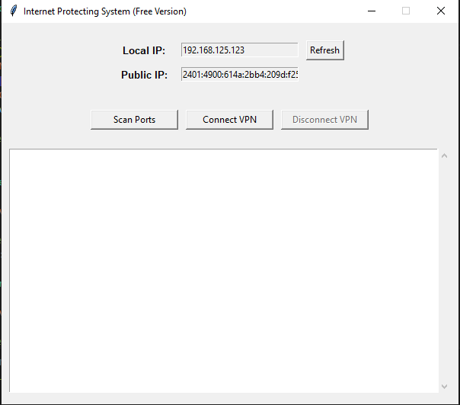

Figure 1: Image from Demo version with the system’s

IP fetched automatically

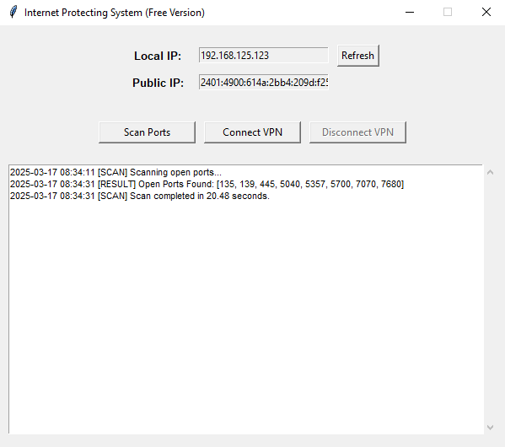

Figure 2: Scanned report for Open ports in the

system in demo version

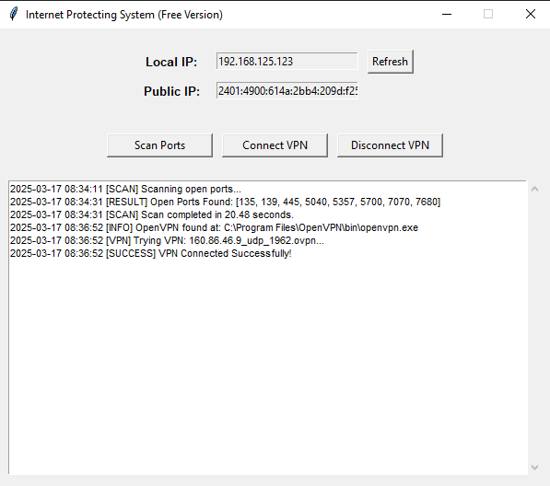

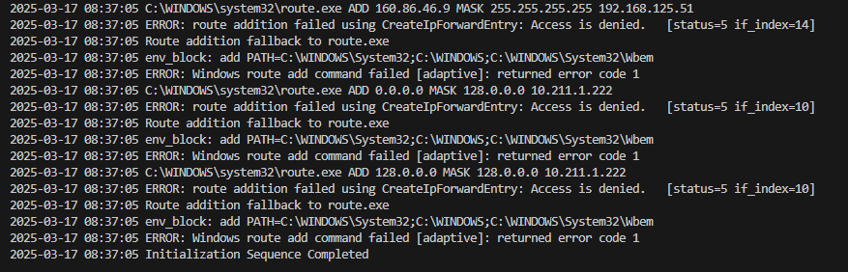

Figure 3, Figure 4: VPN connectivity in Demo version

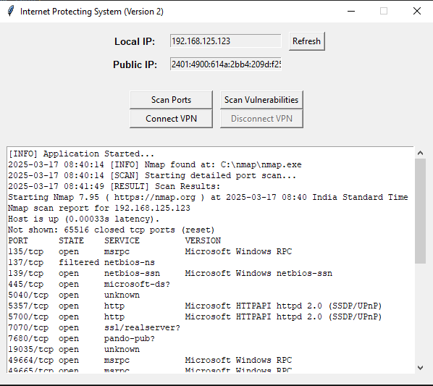

Figure 5: Scan Open ports output from the Premium Lite

version with help of Nmap

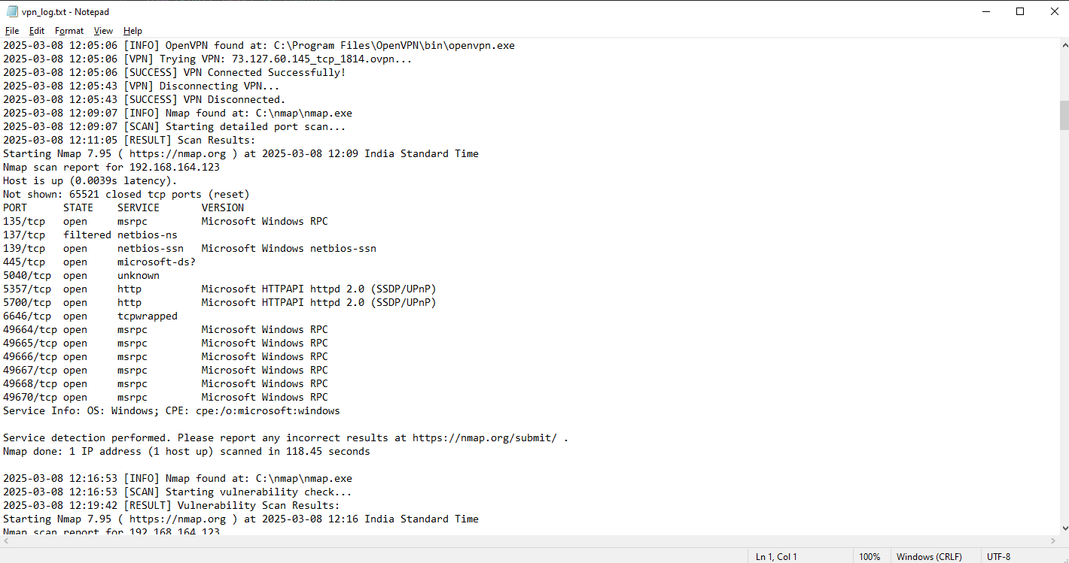

Figure 6: Logging System that automatically stores

the details of action in logs\activity.txt